JAVA PROJECT



TEAM

S.Harshini -23WH1A05C9 – CSE-C

K.Manya Sree – 23WH1A05H4 – CSE C

D.Shiva Sohanasri – 23WH1A05H7 – CSE C

Project Title: BANK MANAGEMENT SYSTEM

**Project Description**: This project is a simple Bank Management System implemented in java using Java Graphical User Interface (GUI).

The **Bank Management System** is a Java-based application developed to enhance and streamline banking operations through an intuitive graphical user interface (GUI). Built using Java Swing, this project demonstrates the effective use of Swing components such as labels, text fields, buttons, and panels to create a cohesive and user-friendly experience. The system offers multiple registration pages, including a login page, application forms for account creation, and additional details forms, allowing a step-by-step registration and onboarding process for new customers.

The ATM interface allows users to log in with their card number and PIN, offering secure access to account features such as balance inquiries, deposits, withdrawals, and transfers. For new users, a comprehensive application form is available, collecting detailed personal and financial information through a multi-step form to ensure all necessary data is gathered securely and efficiently.

In addition to customer features, the system includes an administrator module, enabling bank staff to view and manage customer accounts, monitor transactions, and generate reports. The back-end integration with a database ensures data persistence and reliability, while the modular approach allows for future enhancements such as OTP verification and email notifications.

This project provides a robust and secure platform for managing banking operations, reducing manual tasks, and improving service efficiency. It also demonstrates effective use of Java and database management to create a practical, real-world banking application.

**Source Code:**

**Login page:**

package bank.management.system;  
  
import javax.swing.*;  
import java.awt.*;  
import java.awt.event.ActionEvent;  
import java.awt.event.ActionListener;  
import java.sql.ResultSet;  
  
public class Login extends JFrame implements ActionListener {  
 JLabel label1, label2, label3;  
 JTextField textField2;  
 JPasswordField passwordField3;  
  
 JButton button1,button2,button3;  
 Login(){  
 super("Bank Management System");  
 ImageIcon i1 = new ImageIcon(ClassLoader.getSystemResource("bank.png"));  
 Image i2 = i1.getImage().getScaledInstance(100,100,Image.SCALE_DEFAULT);  
 ImageIcon i3 = new ImageIcon(i2);  
 JLabel image = new JLabel(i3);  
 image.setBounds(350,10,100,100);  
 add(image);  
  
 ImageIcon ii1 = new ImageIcon(ClassLoader.getSystemResource("card.png"));  
 Image ii2 = ii1.getImage().getScaledInstance(100,100,Image.SCALE_DEFAULT);  
 ImageIcon ii3 = new ImageIcon(ii2);  
 JLabel iimage = new JLabel(ii3);  
 iimage.setBounds(630,350,100,100);  
 add(iimage);  
  
 label1 = new JLabel("WELCOME TO ATM");  
 label1.setForeground(Color.WHITE);  
 label1.setFont(new Font("AvantGarde", Font.BOLD, 38));  
 label1.setBounds(230,125,450,40);  
 add(label1);  
  
 label2 = new JLabel("Card No:");  
 label2.setFont(new Font("Ralway", Font.BOLD, 28));  
 label2.setForeground(Color.WHITE);  
 label2.setBounds(150,190,375,30);  
 add(label2);  
  
 textField2 = new JTextField(15);  
 textField2.setBounds(325,190,230,30);  
 textField2.setFont(new Font("Arial", Font.BOLD,14));  
 add(textField2);  
  
 label3 = new JLabel("PIN: ");  
 label3.setFont(new Font("Ralway", Font.BOLD, 28));  
 label3.setForeground(Color.WHITE);  
 label3.setBounds(150,250,375,30);  
 add(label3);  
  
 passwordField3 = new JPasswordField(15);  
 passwordField3.setBounds(325,250,230,30);  
 passwordField3.setFont(new Font("Arial", Font.BOLD, 14));  
 add(passwordField3);  
  
 button1 = new JButton("SIGN IN");  
 button1.setFont(new Font("Arial", Font.BOLD, 14));  
 button1.setForeground(Color.WHITE);  
 button1.setBackground(Color.BLACK);  
 button1.setBounds(300,300,100, 30);  
 button1.addActionListener(this);  
 add(button1);  
  
 button2 = new JButton("CLEAR");  
 button2.setFont(new Font("Arial", Font.BOLD, 14));  
 button2.setForeground(Color.WHITE);  
 button2.setBackground(Color.BLACK);  
 button2.setBounds(430,300,100, 30);  
 button2.addActionListener(this);  
 add(button2);  
  
 button3 = new JButton("SIGN UP");  
 button3.setFont(new Font("Arial", Font.BOLD, 14));  
 button3.setForeground(Color.WHITE);  
 button3.setBackground(Color.BLACK);  
 button3.setBounds(300,350,230, 30);  
 button3.addActionListener(this);  
 add(button3);  
  
 ImageIcon iii1 = new ImageIcon(ClassLoader.getSystemResource("backbg.png"));  
 Image iii2 = iii1.getImage().getScaledInstance(850,480,Image.SCALE_DEFAULT);  
 ImageIcon iii3 = new ImageIcon(iii2);  
 JLabel iiimage = new JLabel(iii3);  
 iiimage.setBounds(0,0,850,480);  
 add(iiimage);  
  
  
 setLayout(null);  
 setSize(850,480);  
 setLocation(450,200);  
   
 setVisible(true);  
 }  
   
   
 public void actionPerformed(ActionEvent e) {  
 try{  
 if (e.getSource()==button1){  
 Connn c = new Connn();  
 String cardno = textField2.getText();  
 String pin = passwordField3.getText();  
 String q = "select * from login where card_number = '"+cardno+"' and pin = '"+pin+"'";  
 ResultSet resultSet = c.statement.executeQuery(q);  
 if (resultSet.next()){  
 setVisible(false);  
 new main_Class("");  
 }else {  
 JOptionPane.showMessageDialog(null,"Incorrect Card Number or PIN");  
 }  
  
 }else if (e.getSource() == button2){  
 textField2.setText("");  
 passwordField3.setText("");  
 }else if (e.getSource() == button3){  
 new Signup();  
 setVisible(false);  
 }  
 }catch (Exception E){  
 E.printStackTrace();  
 }  
  
 }  
  
 public static void main(String[] args) {  
 new Login();  
 }  
}

**Output:**

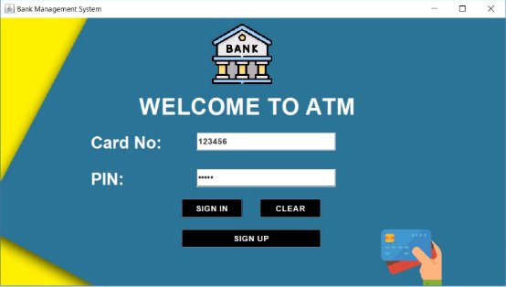

**Registration page(1):**

package bank.management.system;

import com.toedter.calendar.JDateChooser;

import javax.swing.*;

import java.awt.*;

import java.awt.event.ActionEvent;

import java.awt.event.ActionListener;

import java.util.Random;

public class Signup extends JFrame implements ActionListener {

JRadioButton r1,r2,m1,m2,m3;

JButton next;

JTextField textName ,textFname, textEmail,textAdd,textcity,textState,textPin;

JDateChooser dateChooser;

Random ran = new Random();

long first4 =(ran.nextLong() % 9000L) +1000L;

String first = " " + Math.abs(first4);

Signup(){

super ("APPLICATION FORM");

ImageIcon i1 = new ImageIcon(ClassLoader.getSystemResource("bank.png"));

Image i2 = i1.getImage().getScaledInstance(100,100,Image.SCALE_DEFAULT);

ImageIcon i3 = new ImageIcon(i2);

JLabel image = new JLabel(i3);

image.setBounds(25,10,100,100);

add(image);

JLabel label1 = new JLabel("APPLICATION FORM NO."+ first);

label1.setBounds(160,20,600,40);

label1.setFont(new Font("Raleway",Font.BOLD,38));

add(label1);

JLabel label2 = new JLabel("Page 1");

label2.setFont(new Font("Ralway",Font.BOLD, 22));

label2.setBounds(330,70,600,30);

add(label2);

JLabel label3 = new JLabel("Personal Details");

label3.setFont(new Font("Raleway", Font.BOLD,22));

label3.setBounds(290,90,600,30);

add(label3);

JLabel labelName = new JLabel("Name :");

labelName.setFont(new Font("Raleway", Font.BOLD, 20));

labelName.setBounds(100,190,100,30);

add(labelName);

textName = new JTextField();

textName.setFont(new Font("Raleway",Font.BOLD, 14));

textName.setBounds(300,190,400,30);

add(textName);

JLabel labelfName = new JLabel("Father's Name :");

labelfName.setFont(new Font("Raleway", Font.BOLD, 20));

labelfName.setBounds(100,240,200,30);

add(labelfName);

textFname = new JTextField();

textFname.setFont(new Font("Raleway",Font.BOLD, 14));

textFname.setBounds(300,240,400,30);

add(textFname);

JLabel DOB = new JLabel("Date of Birth");

DOB.setFont(new Font("Raleway", Font.BOLD, 20));

DOB.setBounds(100,340,200,30);

add(DOB);

dateChooser = new JDateChooser();

dateChooser.setForeground(new Color(105,105,105));

dateChooser.setBounds(300,340,400,30);

add(dateChooser);

JLabel labelG = new JLabel("Gender");

labelG.setFont(new Font("Raleway", Font.BOLD, 20));

labelG.setBounds(100,290,200,30);

add(labelG);

r1 = new JRadioButton("Male");

r1.setFont(new Font("Raleway", Font.BOLD,14));

r1.setBackground(new Color(222,255,228));

r1.setBounds(300,290,60,30);

add(r1);

r2 = new JRadioButton("Female");

r2.setBackground(new Color(222,255,228));

r2.setFont(new Font("Raleway", Font.BOLD,14));

r2.setBounds(450,290,90,30);

add(r2);

ButtonGroup buttonGroup = new ButtonGroup();

buttonGroup.add(r1);

buttonGroup.add(r2);

JLabel labelEmail = new JLabel("Email address :");

labelEmail.setFont(new Font("Raleway", Font.BOLD, 20));

labelEmail.setBounds(100,390,200,30);

add(labelEmail);

textEmail = new JTextField();

textEmail.setFont(new Font("Raleway",Font.BOLD, 14));

textEmail.setBounds(300,390,400,30);

add(textEmail);

JLabel labelMs = new JLabel("Marital Status :");

labelMs.setFont(new Font("Raleway", Font.BOLD, 20));

labelMs.setBounds(100,440,200,30);

add(labelMs);

m1 = new JRadioButton("Married");

m1.setBounds(300,440,100,30);

m1.setBackground(new Color(222,255,228));

m1.setFont(new Font("Raleway", Font.BOLD,14));

add(m1);

m2 = new JRadioButton("Unmarried");

m2.setBackground(new Color(222,255,228));

m2.setBounds(450,440,100,30);

m2.setFont(new Font("Raleway", Font.BOLD,14));

add(m2);

m3 = new JRadioButton("Other");

m3.setBackground(new Color(222,255,228));

m3.setBounds(635,440,100,30);

m3.setFont(new Font("Raleway", Font.BOLD,14));

add(m3);

ButtonGroup buttonGroup1 = new ButtonGroup();

buttonGroup1.add(m1);

buttonGroup1.add(m2);

buttonGroup1.add(m3);

JLabel labelAdd = new JLabel("Address :");

labelAdd.setFont(new Font("Raleway", Font.BOLD, 20));

labelAdd.setBounds(100,490,200,30);

add(labelAdd);

textAdd = new JTextField();

textAdd.setFont(new Font("Raleway",Font.BOLD, 14));

textAdd.setBounds(300,490,400,30);

add(textAdd);

JLabel labelCity = new JLabel("City :");

labelCity.setFont(new Font("Raleway", Font.BOLD, 20));

labelCity.setBounds(100,540,200,30);

add(labelCity);

textcity = new JTextField();

textcity.setFont(new Font("Raleway",Font.BOLD, 14));

textcity.setBounds(300,540,400,30);

add(textcity);

JLabel labelPin = new JLabel("Pin Code :");

labelPin.setFont(new Font("Raleway", Font.BOLD, 20));

labelPin.setBounds(100,590,200,30);

add(labelPin);

textPin = new JTextField();

textPin.setFont(new Font("Raleway",Font.BOLD, 14));

textPin.setBounds(300,590,400,30);

add(textPin);

JLabel labelstate = new JLabel("State :");

labelstate.setFont(new Font("Raleway", Font.BOLD, 20));

labelstate.setBounds(100,640,200,30);

add( labelstate);

textState = new JTextField();

textState.setFont(new Font("Raleway",Font.BOLD, 14));

textState.setBounds(300,640,400,30);

add(textState);

next = new JButton("Next");

next.setFont(new Font("Raleway",Font.BOLD, 14));

next.setBackground(Color.BLACK);

next.setForeground(Color.WHITE);

next.setBounds(620,710,80,30);

next.addActionListener(this);

add(next);

getContentPane().setBackground(new Color(222,255,228));

setLayout(null);

setSize(850,800);

setLocation(360,40);

setVisible(true);

}

@Override

public void actionPerformed(ActionEvent e) {

String formno = first;

String name = textName.getText();

String fname = textFname.getText();

String dob = ((JTextField) dateChooser.getDateEditor().getUiComponent()).getText();

String gender = null;

if(r1.isSelected()){

gender = "Male";

}else if (r2.isSelected()){

gender = "Female";

}

String email = textEmail.getText();

String marital =null;

if (m1.isSelected()){

marital = "Married";

} else if (m2.isSelected()) {

marital = "Unmarried";

} else if (m3.isSelected()) {

marital = "Other";}

String address = textAdd.getText();

String city = textcity.getText();

String pincode = textPin.getText();

String state = textState.getText();

try{

if (textName.getText().equals("")){

JOptionPane.showMessageDialog(null, "Fill all the fields");

}else {

Connn con1 = new Connn();

String q = "insert into signup values('"+formno+"', '"+name+"','"+fname+"','"+dob+"','"+gender+"','"+email+"','"+marital+"', '"+address+"', '"+city+"','"+pincode+"','"+state+"' )";

con1.statement.executeUpdate(q);

new Signup2(formno);

setVisible(false);

}

}catch (Exception E){

E.printStackTrace();

}}

public static void main(String[] args) {

new Signup();

}

}

**Output:**

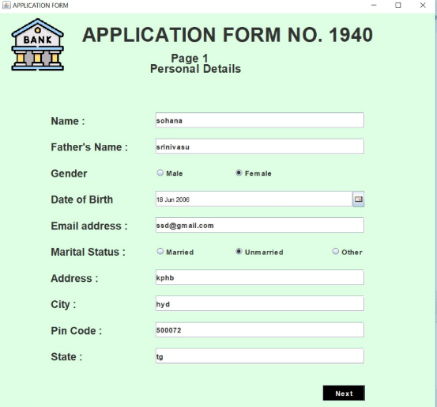

**Registration Page (2):**

package bank.management.system;  
  
import javax.swing.*;  
import java.awt.*;  
import java.awt.event.ActionEvent;  
import java.awt.event.ActionListener;  
  
public class Signup2 extends JFrame implements ActionListener {  
JComboBox comboBox,comboBox2,comboBox3,comboBox4,comboBox5;  
 JTextField textPan,textAadhar;  
 JRadioButton r1,r2, e1,e2;  
 JButton next;  
 String formno;  
   
 Signup2(String formno){   
 super("APPLICATION FORM");  
  
 ImageIcon i1 = new ImageIcon(ClassLoader.getSystemResource("bank.png"));  
 Image i2 = i1.getImage().getScaledInstance(100,100,Image.SCALE_DEFAULT);  
 ImageIcon i3 = new ImageIcon(i2);  
 JLabel image = new JLabel(i3);  
 image.setBounds(150,5,100,100);  
 add(image);  
 this.formno = formno;  
 JLabel l1 = new JLabel("Page 2 :-");  
 l1.setFont(new Font("Raleway", Font.BOLD,22));  
 l1.setBounds(300,30,600,40);  
 add(l1);  
  
 JLabel l2 = new JLabel("Additonal Details");  
 l2.setFont(new Font("Raleway", Font.BOLD,22));  
 l2.setBounds(300,60,600,40);  
 add(l2);  
  
 JLabel l3 = new JLabel("Religion :");  
 l3.setFont(new Font("Raleway", Font.BOLD,18));  
 l3.setBounds(100,120,100,30);  
 add(l3);  
   
 String religion[] = {"Hindu","Muslim","Sikh", "Christian", "Other"};  
 comboBox = new JComboBox(religion);  
 comboBox.setBackground(new Color(252,208,76));  
 comboBox.setFont(new Font("Raleway",Font.BOLD,14));  
 comboBox.setBounds(350,120,320,30);  
 add(comboBox);  
  
 JLabel l4 = new JLabel("Category : ");  
 l4.setFont(new Font("Raleway", Font.BOLD,18));  
 l4.setBounds(100,170,100,30);  
 add(l4);  
  
 String Category [] = {"General","OBC","SC", "ST", "Other"};  
 comboBox2 = new JComboBox(Category);  
 comboBox2.setBackground(new Color(252,208,76));  
 comboBox2.setFont(new Font("Raleway",Font.BOLD,14));  
 comboBox2.setBounds(350,170,320,30);  
 add(comboBox2);  
   
 JLabel l5 = new JLabel("Income : ");  
 l5.setFont(new Font("Raleway", Font.BOLD,18));  
 l5.setBounds(100,220,100,30);  
 add(l5);  
  
 String income [] = {"Null","<1,50,000","<2,50,000", "5,00,000", "Uptp 10,00,000","Above 10,00,000"};  
 comboBox3 = new JComboBox(income);  
 comboBox3.setBackground(new Color(252,208,76));  
 comboBox3.setFont(new Font("Raleway",Font.BOLD,14));  
 comboBox3.setBounds(350,220,320,30);  
 add(comboBox3);  
  
 JLabel l6 = new JLabel("Educational : ");  
 l6.setFont(new Font("Raleway", Font.BOLD,18));  
 l6.setBounds(100,270,150,30);  
 add(l6);  
  
 String educational [] = {"Non-Graduate","Graduate","Post-Graduate", "Doctrate", "Others"};  
 comboBox4 = new JComboBox(educational);  
 comboBox4.setBackground(new Color(252,208,76));  
 comboBox4.setFont(new Font("Raleway",Font.BOLD,14));  
 comboBox4.setBounds(350,270,320,30);  
 add(comboBox4);  
  
  
 JLabel l7 = new JLabel("Occupation : ");  
 l7.setFont(new Font("Raleway", Font.BOLD,18));  
 l7.setBounds(100,340,150,30);  
 add(l7);  
  
 String Occupation [] = {"Salaried","Self-Employed","Business", "Student", "Retired", "Other"};  
 comboBox5 = new JComboBox(Occupation);  
 comboBox5.setBackground(new Color(252,208,76));  
 comboBox5.setFont(new Font("Raleway",Font.BOLD,14));  
 comboBox5.setBounds(350,340,320,30);  
 add(comboBox5);  
  
 JLabel l8 = new JLabel("PAN Number : ");  
 l8.setFont(new Font("Raleway", Font.BOLD,18));  
 l8.setBounds(100,390,150,30);  
 add(l8);  
  
 textPan = new JTextField();  
 textPan.setFont(new Font("Raleway", Font.BOLD,18));  
 textPan.setBounds(350,390,320,30);  
 add(textPan);  
   
 JLabel l9 = new JLabel("Aadhar Number : ");  
 l9.setFont(new Font("Raleway", Font.BOLD,18));  
 l9.setBounds(100,440,180,30);  
 add(l9);  
  
 textAadhar = new JTextField();  
 textAadhar.setFont(new Font("Raleway", Font.BOLD,18));  
 textAadhar.setBounds(350,440,320,30);  
 add(textAadhar);  
  
 JLabel l10 = new JLabel("Senior Citizen : ");  
 l10.setFont(new Font("Raleway", Font.BOLD,18));  
 l10.setBounds(100,490,180,30);  
 add(l10);  
  
 r1 = new JRadioButton("Yes");  
 r1.setFont(new Font("Raleway", Font.BOLD,14));  
 r1.setBackground(new Color(252,208,76));  
 r1.setBounds(350,490,100,30);  
 add(r1);  
 r2 = new JRadioButton("No");  
 r2.setFont(new Font("Raleway", Font.BOLD,14));  
 r2.setBackground(new Color(252,208,76));  
 r2.setBounds(460,490,100,30);  
 add(r2);  
  
 JLabel l11 = new JLabel("Existing Account : ");  
 l11.setFont(new Font("Raleway", Font.BOLD,18));  
 l11.setBounds(100,540,180,30);  
 add(l11);  
  
 e1 = new JRadioButton("Yes");  
 e1.setFont(new Font("Raleway", Font.BOLD,14));  
 e1.setBackground(new Color(252,208,76));  
 e1.setBounds(350,540,100,30);  
 add(e1);  
 e2 = new JRadioButton("No");  
 e2.setFont(new Font("Raleway", Font.BOLD,14));  
 e2.setBackground(new Color(252,208,76));  
 e2.setBounds(460,540,100,30);  
 add(e2);  
  
 JLabel l12 = new JLabel("Form No : ");  
 l12.setFont(new Font("Raleway", Font.BOLD,14));  
 l12.setBounds(700,10,100,30);  
 add(l12);  
  
 JLabel l13 = new JLabel(formno);  
 l13.setFont(new Font("Raleway", Font.BOLD,14));  
 l13.setBounds(760,10,60,30);  
 add(l13);  
  
 next = new JButton("Next");  
 next.setFont(new Font("Raleway",Font.BOLD,14));  
 next.setBackground(Color.WHITE);  
 next.setForeground(Color.BLACK);  
 next.setBounds(570,640,100,30);  
 next.addActionListener(this);  
 add(next);  
  
   
 setLayout(null);  
 setSize(850,750);  
 setLocation(450,80);  
 getContentPane().setBackground(new Color(252, 208, 76));  
 setVisible(true);  
 }  
  
 @Override  
 public void actionPerformed(ActionEvent e) {  
 String rel = (String) comboBox.getSelectedItem();  
 String cate = (String) comboBox2.getSelectedItem();  
 String inc = (String) comboBox3.getSelectedItem();  
 String edu = (String) comboBox4.getSelectedItem();  
 String occ = (String) comboBox5.getSelectedItem();  
  
 String pan = textPan.getText();  
 String addhar = textAadhar.getText();  
   
 String scitizen = " ";  
 if ((r1.isSelected())){  
 scitizen = "Yes";  
 } else if (r2.isSelected()) {  
 scitizen ="No";  
 }  
 String eAccount = " ";  
 if ((r1.isSelected())){  
 eAccount = "Yes";  
 } else if (r2.isSelected()) {  
 eAccount ="No";  
 }  
  
 try{  
 if (textPan.getText().equals("") || textAadhar.getText().equals("")){  
 JOptionPane.showMessageDialog(null,"Fill all the fields");  
 }else {  
 Connn c = new Connn();  
 String q = "insert into Signuptwo values('"+formno+"', '"+rel+"', '"+cate+"','"+inc+"','"+edu+"','"+occ+"','"+pan+"','"+addhar+"','"+scitizen+"','"+eAccount+"')";  
 c.statement.executeUpdate(q);  
 new Signup3(formno);  
 setVisible(false);  
 }  
  
  
 }catch (Exception E){  
 E.printStackTrace();  
 }  
}  
   
public static void main(String[] args) {  
 new Signup2("");  
 }  
}

**Output:**

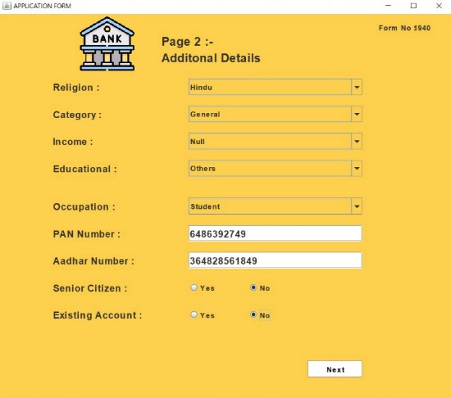

Registration Page(3):

package bank.management.system;  
  
import javax.print.attribute.standard.JobHoldUntil;  
import javax.swing.*;  
import java.awt.*;  
import java.awt.event.ActionEvent;  
import java.awt.event.ActionListener;  
import java.rmi.server.ExportException;  
import java.util.Random;  
  
public class Signup3 extends JFrame implements ActionListener {  
JRadioButton r1,r2,r3,r4;  
 JCheckBox c1,c2,c3,c4,c5,c6;  
 JButton s,c;  
 String formno;  
 Signup3(String formno){  
  
 this.formno = formno;  
   
 ImageIcon i1 = new ImageIcon(ClassLoader.getSystemResource("bank.png"));  
 Image i2 = i1.getImage().getScaledInstance(100,100,Image.SCALE_DEFAULT);  
 ImageIcon i3 = new ImageIcon(i2);  
 JLabel image = new JLabel(i3);  
 image.setBounds(150,5,100,100);  
 add(image);  
  
 JLabel l1 = new JLabel("Page 3:");  
 l1.setFont(new Font("Raleway",Font.BOLD,22));  
 l1.setBounds(280,40,400,40);  
 add(l1);  
  
 JLabel l2 = new JLabel("Account Details");  
 l2.setFont(new Font("Raleway",Font.BOLD,22));  
 l2.setBounds(280,70,400,40);  
 add(l2);  
   
 JLabel l3 = new JLabel("Account Type:");  
 l3.setFont(new Font("Raleway",Font.BOLD,18));  
 l3.setBounds(100,140,200,30);  
 add(l3);  
  
 r1 = new JRadioButton("Saving Account");  
 r1.setFont(new Font("Raleway",Font.BOLD,16));  
 r1.setBackground(new Color(215,252,252));  
 r1.setBounds(100,180,150,30);  
 add(r1);  
  
 r2 = new JRadioButton("Fixed Deposit Account");  
 r2.setFont(new Font("Raleway",Font.BOLD,16));  
 r2.setBackground(new Color(215,252,252));  
 r2.setBounds(350,180,300,30);  
 add(r2);  
  
 r3 = new JRadioButton("Current Account");  
 r3.setFont(new Font("Raleway",Font.BOLD,16));  
 r3.setBackground(new Color(215,252,252));  
 r3.setBounds(100,220,250,30);  
 add(r3);  
  
 r4 = new JRadioButton("Recurring Deposit Account");  
 r4.setFont(new Font("Raleway",Font.BOLD,16));  
 r4.setBackground(new Color(215,252,252));  
 r4.setBounds(350,220,250,30);  
 add(r4);  
   
 ButtonGroup buttonGroup = new ButtonGroup();  
 buttonGroup.add(r1);  
 buttonGroup.add(r2);  
 buttonGroup.add(r3);  
 buttonGroup.add(r4);  
  
 JLabel l4 = new JLabel("Card Number:");  
 l4.setFont(new Font("Raleway",Font.BOLD,18));  
 l4.setBounds(100,300,200,30);  
 add(l4);  
   
 JLabel l5 = new JLabel("(Your 16-digit Card Number)");  
 l5.setFont(new Font("Raleway",Font.BOLD,12));  
 l5.setBounds(100,330,200,20);  
 add(l5);  
  
 JLabel l6 = new JLabel("XXXX-XXXX-XXXX-4841");  
 l6.setFont(new Font("Raleway",Font.BOLD,18));  
 l6.setBounds(330,300,250,30);  
 add(l6);  
  
 JLabel l7 = new JLabel("(It would appear on atm card/cheque Book and Statements)");  
 l7.setFont(new Font("Raleway",Font.BOLD,12));  
 l7.setBounds(330,330,500,20);  
 add(l7);  
  
 JLabel l8 = new JLabel("PIN:");  
 l8.setFont(new Font("Raleway",Font.BOLD,18));  
 l8.setBounds(100,370,200,30);  
 add(l8);  
  
 JLabel l9 = new JLabel("XXXX");  
 l9.setFont(new Font("Raleway",Font.BOLD,18));  
 l9.setBounds(330,370,200,30);  
 add(l9);  
  
 JLabel l10 = new JLabel("(4-digit Password)");  
 l10.setFont(new Font("Raleway",Font.BOLD,12));  
 l10.setBounds(100,400,200,20);  
 add(l10);  
  
 JLabel l11 = new JLabel("Services Required:");  
 l11.setFont(new Font("Raleway",Font.BOLD,18));  
 l11.setBounds(100,450,200,30);  
 add(l11);  
  
 c1 = new JCheckBox("ATM CARD");  
 c1.setBackground(new Color(215,252,252));  
 c1.setFont(new Font("Raleway",Font.BOLD,16));  
 c1.setBounds(100,500,200,30);  
 add(c1);  
  
 c2 = new JCheckBox("Internet Banking");  
 c2.setBackground(new Color(215,252,252));  
 c2.setFont(new Font("Raleway",Font.BOLD,16));  
 c2.setBounds(350,500,200,30);  
 add(c2);  
  
 c3 = new JCheckBox("Mobile Banking");  
 c3.setBackground(new Color(215,252,252));  
 c3.setFont(new Font("Raleway",Font.BOLD,16));  
 c3.setBounds(100,550,200,30);  
 add(c3);  
  
 c4 = new JCheckBox("EMAIL Alerts");  
 c4.setBackground(new Color(215,252,252));  
 c4.setFont(new Font("Raleway",Font.BOLD,16));  
 c4.setBounds(350,550,200,30);  
 add(c4);  
  
 c5 = new JCheckBox("Cheque Book");  
 c5.setBackground(new Color(215,252,252));  
 c5.setFont(new Font("Raleway",Font.BOLD,16));  
 c5.setBounds(100,600,200,30);  
 add(c5);  
  
 c6 = new JCheckBox("E-Statement");  
 c6.setBackground(new Color(215,252,252));  
 c6.setFont(new Font("Raleway",Font.BOLD,16));  
 c6.setBounds(350,600,200,30);  
 add(c6);  
  
 JCheckBox c7 = new JCheckBox("I here by decleares that the above entered details correct to the best of my knlowledge.",true);  
 c7.setBackground(new Color(215,252,252));  
 c7.setFont(new Font("Raleway",Font.BOLD,12));  
 c7.setBounds(100,680,600,20);  
 add(c7);  
  
 JLabel l12 = new JLabel("Form No : ");  
 l12.setFont(new Font("Raleway", Font.BOLD,14));  
 l12.setBounds(700,10,100,30);  
 add(l12);  
  
 JLabel l13 = new JLabel(formno);  
 l13.setFont(new Font("Raleway", Font.BOLD,14));  
 l13.setBounds(760,10,60,30);  
 add(l13);  
   
 s = new JButton("Submit");  
 s.setFont(new Font("Raleway", Font.BOLD,14));  
 s.setBackground(Color.BLACK);  
 s.setForeground(Color.WHITE);  
 s.setBounds(250,720,100,30);  
 s.addActionListener(this);  
 add(s);  
  
 c = new JButton("Cancel");  
 c.setFont(new Font("Raleway", Font.BOLD,14));  
 c.setBackground(Color.BLACK);  
 c.setForeground(Color.WHITE);  
 c.setBounds(420,720,100,30);  
 c.addActionListener(this);  
 add(c);  
  
  
 getContentPane().setBackground(new Color(215,252,252));  
 setSize(850,800);  
 setLayout(null);  
 setLocation(400,20);  
 setVisible(true);  
 }  
  
   
@Override  
 public void actionPerformed(ActionEvent e) {  
 String atype = null;  
 if (r1.isSelected()){  
 atype = "Saving Account";  
 } else if (r2.isSelected()) {  
 atype ="Fixed Deposit Account";  
 }else if (r3.isSelected()){  
 atype ="Current Account";  
 }else if (r4.isSelected()){  
 atype = "Recurring Deposit Account";  
 }  
  
 Random ran = new Random();  
 long first7 = (ran.nextLong() % 90000000L) + 1409963000000000L;  
 String cardno = "" + Math.abs(first7);  
  
 long first3 = (ran.nextLong() % 9000L)+ 1000L;  
 String pin = "" + Math.abs(first3);  
  
 String fac = "";  
 if(c1.isSelected()){  
 fac = fac+"ATM CARD ";  
 } else if (c2.isSelected()) {  
 fac = fac+"Internet Banking";  
 } else if (c3.isSelected()) {  
 fac = fac+"Mobile Banking";  
 } else if (c4.isSelected()) {  
 fac = fac+"EMAIL Alerts";  
 } else if (c5.isSelected()) {  
 fac=fac+"Cheque Book";  
 } else if (c6.isSelected()) {  
 fac=fac+"E-Statement";  
 }  
   
 try {  
 if (e.getSource()==s){  
 if (atype.equals("")){  
 JOptionPane.showMessageDialog(null,"Fill all the fields");  
 }else {  
 Connn c1 = new Connn();  
 String q1 = "insert into signupthree values('"+formno+"', '"+atype+"','"+cardno+"','"+pin+"','"+fac+"')";  
 String q2 = "insert into login values('"+formno+"','"+cardno+"','"+pin+"')";  
 c1.statement.executeUpdate(q1);  
 c1.statement.executeUpdate(q2);  
 JOptionPane.showMessageDialog(null,"Card Number : "+cardno+"\n Pin : "+pin );  
 new Deposit(pin);  
 setVisible(false);  
 }  
 } else if (e.getSource()==c) {  
 System.exit(0);  
 }  
  
 }catch (Exception E){  
 E.printStackTrace();  
 }  
  
 }  
  
public static void main(String[] args) {  
 new Signup3("");  
 }  
}

Output:

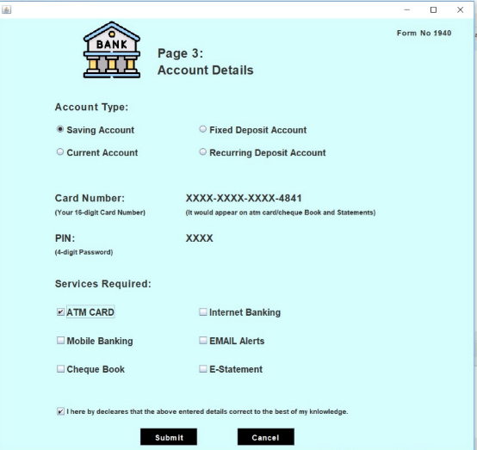

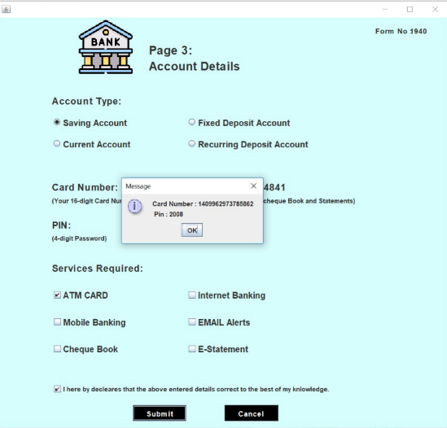

Connecting java code to Database:

**package** bank.management.system;

**import** java.sql.*;

**public** **class** Connn {

Connection connection;

Statement statement;

**public** Connn(){

**try**{

connection = DriverManager.*getConnection*("jdbc:mysql://localhost:3306/bankSystem","root","1234");

statement = connection.createStatement();

}**catch** (Exception e){

e.printStackTrace();

}

}

}

Main Class Code (ATM Stimulator):

package bank.management.system;  
  
import javax.swing.*;  
import java.awt.*;  
import java.awt.event.ActionEvent;  
import java.awt.event.ActionListener;  
  
public class main_Class extends JFrame implements ActionListener {  
JButton b1,b2,b3,b4,b6,b7;  
 String pin;  
   
main_Class(String pin){  
this.pin=pin;  
ImageIcon i1 = new ImageIcon(ClassLoader.getSystemResource("atm2.png"));  
 Image i2 = i1.getImage().getScaledInstance(1550,830,Image.SCALE_DEFAULT);  
 ImageIcon i3 = new ImageIcon(i2);  
 JLabel l3 = new JLabel(i3);  
 l3.setBounds(0,0,1550,830);  
 add(l3);  
  
 JLabel label = new JLabel("Please Select Your Transaction");  
 label.setBounds(430,180,700,35);  
 label.setForeground(Color.WHITE);  
 label.setFont(new Font("System",Font.BOLD,28));  
 l3.add(label);  
  
 b1 = new JButton("DEPOSIT");  
 b1.setForeground(Color.WHITE);  
 b1.setBackground(new Color(65,125,128));  
 b1.setBounds(410,274,150,35);  
 b1.addActionListener(this);  
 l3.add(b1);  
  
 b2 = new JButton("CASH WITHDRAWL");  
 b2.setForeground(Color.WHITE);  
 b2.setBackground(new Color(65,125,128));  
 b2.setBounds(700,274,150,35);  
 b2.addActionListener(this);  
 l3.add(b2);  
  
 b3 = new JButton("FAST CASH");  
 b3.setForeground(Color.WHITE);  
 b3.setBackground(new Color(65,125,128));  
 b3.setBounds(410,318,150,35);  
 b3.addActionListener(this);  
 l3.add(b3);  
  
 b4 = new JButton("MINI STATEMENT");  
 b4.setForeground(Color.WHITE);  
 b4.setBackground(new Color(65,125,128));  
 b4.setBounds(700,318,150,35);  
 b4.addActionListener(this);  
 l3.add(b4);  
  
   
  
 b6 = new JButton("BALANCE ENQUIRY");  
 b6.setForeground(Color.WHITE);  
 b6.setBackground(new Color(65,125,128));  
 b6.setBounds(700,362,150,35);  
 b6.addActionListener(this);  
 l3.add(b6);  
  
 b7 = new JButton("EXIT");  
 b7.setForeground(Color.WHITE);  
 b7.setBackground(new Color(65,125,128));  
 b7.setBounds(700,406,150,35);  
 b7.addActionListener(this);  
 l3.add(b7);  
  
  
setLayout(null);  
 setSize(1550,1080);  
 setLocation(0,0);  
 setVisible(true);  
  
 }  
  
@Override  
 public void actionPerformed(ActionEvent e) {  
 if (e.getSource()==b1){  
 new Deposit(pin);  
 setVisible(false);  
 }else if (e.getSource()==b7){  
 System.exit(0);  
 } else if (e.getSource()==b2) {  
 new Withdrawl(pin);  
 setVisible(false);  
 } else if (e.getSource()==b6) {  
 new BalanceEnquiry(pin);  
 setVisible(false);  
 } else if (e.getSource()==b3) {  
 new FastCash(pin);  
 setVisible(false);  
 } else if (e.getSource()==b4) {  
 new mini(pin);  
 }  
 }  
public static void main(String[] args) {  
 new main_Class("");  
}  
}

**Output:**

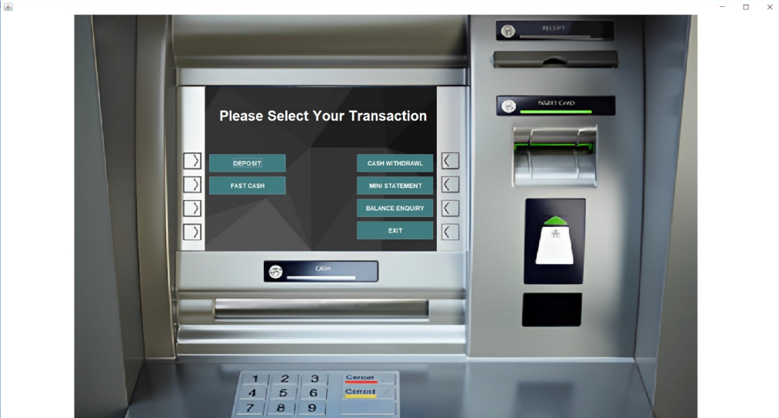

Deposit Page Code:

package bank.management.system;  
  
import javax.swing.*;  
import java.awt.*;  
import java.awt.event.ActionEvent;  
import java.awt.event.ActionListener;  
import java.util.Date;  
  
public class Deposit extends JFrame implements ActionListener{  
String pin;  
TextField textField;  
JButton b1, b2;  
   
Deposit(String pin){  
this.pin = pin;  
  
ImageIcon i1 = new ImageIcon(ClassLoader.getSystemResource("atm2.png"));  
 Image i2 = i1.getImage().getScaledInstance(1550,830,Image.SCALE_DEFAULT);  
 ImageIcon i3 = new ImageIcon(i2);  
 JLabel l3 = new JLabel(i3);  
 l3.setBounds(0,0,1550,830);  
 add(l3);  
  
 JLabel label1 = new JLabel("ENETR AMOUNT YOU WANT TO DEPOSIT");  
 label1.setForeground(Color.WHITE);  
 label1.setFont(new Font("System", Font.BOLD, 16));  
 label1.setBounds(460,180,400,35);  
 l3.add(label1);  
  
 textField = new TextField();  
 textField.setBackground(new Color(65,125,128));  
 textField.setForeground(Color.WHITE);  
 textField.setBounds(460,230,320,25);  
 textField.setFont(new Font("Raleway", Font.BOLD,22));  
 l3.add(textField);  
  
 b1 = new JButton("DEPOSIT");  
 b1.setBounds(700,362,150,35);  
 b1.setBackground(new Color(65,125,128));  
 b1.setForeground(Color.WHITE);  
 b1.addActionListener(this);  
 l3.add(b1);  
  
 b2 = new JButton("BACK");  
 b2.setBounds(700,406,150,35);  
 b2.setBackground(new Color(65,125,128));  
 b2.setForeground(Color.WHITE);  
 b2.addActionListener(this);  
 l3.add(b2);  
   
   
   
setLayout(null);  
 setSize(1550,1080);  
 setLocation(0,0);  
 setVisible(true);  
  
 }  
  
@Override  
 public void actionPerformed(ActionEvent e) {  
 try {  
 String amount = textField.getText();  
 Date date = new Date();  
 if (e.getSource()==b1){  
 if (textField.getText().equals("")){  
 JOptionPane.showMessageDialog(null,"Please enter the Amount you want to Deposit");  
 }else {  
 Connn c = new Connn();  
 c.statement.executeUpdate("insert into bank values('"+pin+"', '"+date+"','Deposit', '"+amount+"')");  
 JOptionPane.showMessageDialog(null,"Rs. "+amount+" Deposited Successfully");  
 setVisible(false);  
 new main_Class(pin);  
 }  
 }else if (e.getSource()==b2){  
 setVisible(false);  
 new main_Class(pin);  
 }  
 }catch (Exception E){  
 E.printStackTrace();  
 }  
}  
public static void main(String[] args) {  
 new Deposit("");  
 }  
}

Output:

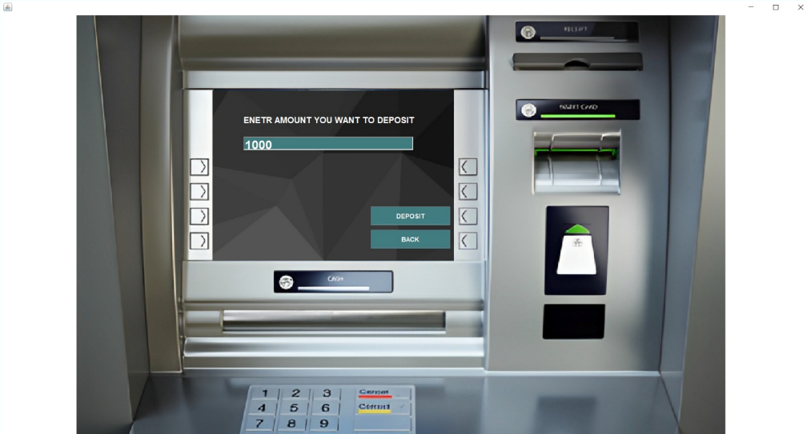

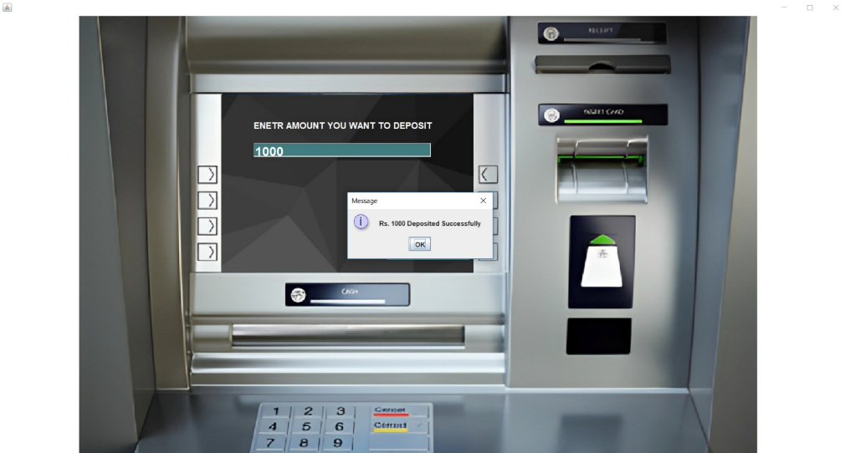

Withdrawl Page Code:

package bank.management.system;

import javax.swing.*;

import java.awt.*;

import java.awt.event.ActionEvent;

import java.awt.event.ActionListener;

import java.sql.ResultSet;

import java.util.Date;

public class Withdrawl extends JFrame implements ActionListener {

String pin;

TextField textField;

JButton b1, b2;

Withdrawl(String pin){

this.pin=pin;

ImageIcon i1 = new ImageIcon(ClassLoader.getSystemResource("atm2.png"));

Image i2 = i1.getImage().getScaledInstance(1550,830,Image.SCALE_DEFAULT);

ImageIcon i3 = new ImageIcon(i2);

JLabel l3 = new JLabel(i3);

l3.setBounds(0,0,1550,830);

add(l3);

JLabel label1 = new JLabel("MAXIMUM WITHDRAWAL IS RS.10,000");

label1.setForeground(Color.WHITE);

label1.setFont(new Font("System", Font.BOLD, 16));

label1.setBounds(460,180,700,35);

l3.add(label1);

JLabel label2 = new JLabel("PLEASE ENTER YOUR AMOUNT");

label2.setForeground(Color.WHITE);

label2.setFont(new Font("System", Font.BOLD, 16));

label2.setBounds(460,220,400,35);

l3.add(label2);

textField = new TextField();

textField.setBackground(new Color(65,125,128));

textField.setForeground(Color.WHITE);

textField.setBounds(460,260,320,25);

textField.setFont(new Font("Raleway", Font.BOLD,22));

l3.add(textField);

b1 = new JButton("WITHDRAW");

b1.setBounds(700,362,150,35);

b1.setBackground(new Color(65,125,128));

b1.setForeground(Color.WHITE);

b1.addActionListener(this);

l3.add(b1);

b2 = new JButton("BACK");

b2.setBounds(700,406,150,35);

b2.setBackground(new Color(65,125,128));

b2.setForeground(Color.WHITE);

b2.addActionListener(this);

l3.add(b2);

setLayout(null);

setSize(1550,1080);

setLocation(0,0);

setVisible(true);

}

@Override

public void actionPerformed(ActionEvent e) {

if(e.getSource()==b1) {

try {

String amount = textField.getText();

Date date = new Date();

if (textField.getText().equals("")) {

JOptionPane.showMessageDialog(null, "Please enter the Amount you want to withdraw");

} else {

Connn c = new Connn();

ResultSet resultSet = c.statement.executeQuery("select * from bank where pin = '" + pin + "'");

int balance = 0;

while (resultSet.next()) {

if (resultSet.getString("type").equals("Deposit")) {

balance += Integer.parseInt(resultSet.getString("amount"));

} else {

balance -= Integer.parseInt(resultSet.getString("amount"));

}

}

if (balance < Integer.parseInt(amount)) {

JOptionPane.showMessageDialog(null, "Insuffient Balance");

return;

}

c.statement.executeUpdate("insert into bank values('" + pin + "', '" + date + "', 'Withdrawl', '" + amount + "' )");

JOptionPane.showMessageDialog(null, "Rs. " + amount + " Debited Successfully");

setVisible(false);

new main_Class(pin);

}

} catch (Exception E) {

}

} else if (e.getSource()==b2) {

setVisible(false);

new main_Class(pin);

}

}

public static void main(String[] args) {

new Withdrawl("");

}

}

**OUTPUT:**

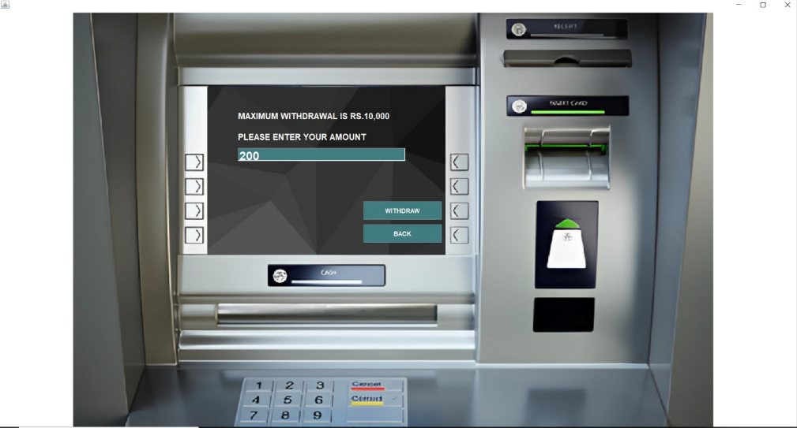

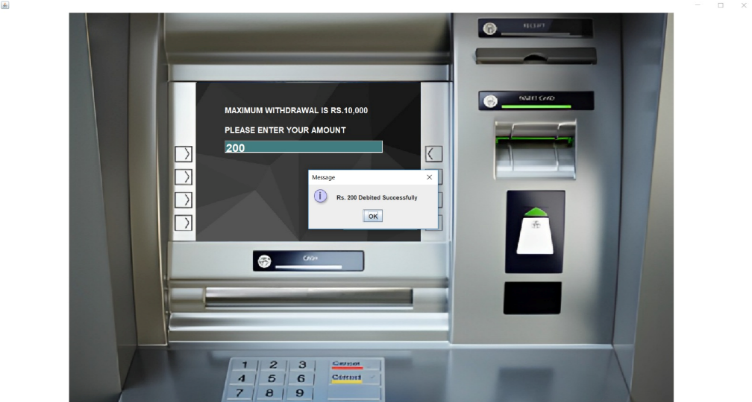

Fast Cash Code:

package bank.management.system;  
  
import javax.swing.*;  
import java.awt.*;  
import java.awt.event.ActionEvent;  
import java.awt.event.ActionListener;  
import java.sql.ResultSet;  
import java.util.Date;  
  
public class FastCash extends JFrame implements ActionListener {  
  
 JButton b1,b2,b3,b4,b5,b6,b7;  
 String pin;  
 FastCash(String pin){  
 this.pin =pin;  
  
 ImageIcon i1 = new ImageIcon(ClassLoader.getSystemResource("atm2.png"));  
 Image i2 = i1.getImage().getScaledInstance(1550,830,Image.SCALE_DEFAULT);  
 ImageIcon i3 = new ImageIcon(i2);  
 JLabel l3 = new JLabel(i3);  
 l3.setBounds(0,0,1550,830);  
 add(l3);  
  
 JLabel label = new JLabel("SELECT WITHDRAWL AMOUNT");  
 label.setBounds(445,180,700,35);  
 label.setForeground(Color.WHITE);  
 label.setFont(new Font("System",Font.BOLD,23));  
 l3.add(label);  
  
 b1 = new JButton("Rs. 100");  
 b1.setForeground(Color.WHITE);  
 b1.setBackground(new Color(65,125,128));  
 b1.setBounds(410,274,150,35);  
 b1.addActionListener(this);  
 l3.add(b1);  
  
 b2 = new JButton("Rs. 500");  
 b2.setForeground(Color.WHITE);  
 b2.setBackground(new Color(65,125,128));  
 b2.setBounds(700,274,150,35);  
 b2.addActionListener(this);  
 l3.add(b2);  
  
 b3 = new JButton("Rs. 1000");  
 b3.setForeground(Color.WHITE);  
 b3.setBackground(new Color(65,125,128));  
 b3.setBounds(410,318,150,35);  
 b3.addActionListener(this);  
 l3.add(b3);  
  
 b4 = new JButton("Rs. 2000");  
 b4.setForeground(Color.WHITE);  
 b4.setBackground(new Color(65,125,128));  
 b4.setBounds(700,318,150,35);  
 b4.addActionListener(this);  
 l3.add(b4);  
  
 b5 = new JButton("Rs. 5000");  
 b5.setForeground(Color.WHITE);  
 b5.setBackground(new Color(65,125,128));  
 b5.setBounds(410,362,150,35);  
 b5.addActionListener(this);  
 l3.add(b5);  
  
 b6 = new JButton("Rs. 10000");  
 b6.setForeground(Color.WHITE);  
 b6.setBackground(new Color(65,125,128));  
 b6.setBounds(700,362,150,35);  
 b6.addActionListener(this);  
 l3.add(b6);  
  
 b7 = new JButton("BACK");  
 b7.setForeground(Color.WHITE);  
 b7.setBackground(new Color(65,125,128));  
 b7.setBounds(700,406,150,35);  
 b7.addActionListener(this);  
 l3.add(b7);  
  
 setLayout(null);  
 setSize(1550,1080);  
 setLocation(0,0);  
 setVisible(true);  
}  
@Override  
 public void actionPerformed(ActionEvent e) {  
 if (e.getSource()==b7) {  
 setVisible(false);  
 new main_Class(pin);  
 }else {  
 String amount = ((JButton)e.getSource()).getText().substring(4);  
 Connn c = new Connn();  
 Date date = new Date();  
 try{  
 ResultSet resultSet = c.statement.executeQuery("select * from bank where pin = '"+pin+"'");  
 int balance =0;  
 while (resultSet.next()){  
 if (resultSet.getString("type").equals("Deposit")){  
 balance += Integer.parseInt(resultSet.getString("amount"));  
 }else {  
 balance -= Integer.parseInt(resultSet.getString("amount"));  
 }  
 }  
 if (e.getSource() != b7 && balance < Integer.parseInt(amount)){  
 JOptionPane.showMessageDialog(null, "Insuffient Balance");  
 return;  
 }  
 c.statement.executeUpdate("insert into bank values('"+pin+"','"+date+"', 'withdrawl', '"+amount+"')");  
 JOptionPane.showMessageDialog(null, "Rs. "+amount+" Debited Successfully");  
 }catch (Exception E){  
 E.printStackTrace();  
 }  
 setVisible(false);  
 new main_Class(pin);  
 }  
}  
 public static void main(String[] args) {  
 new FastCash("");  
 }}

Output:

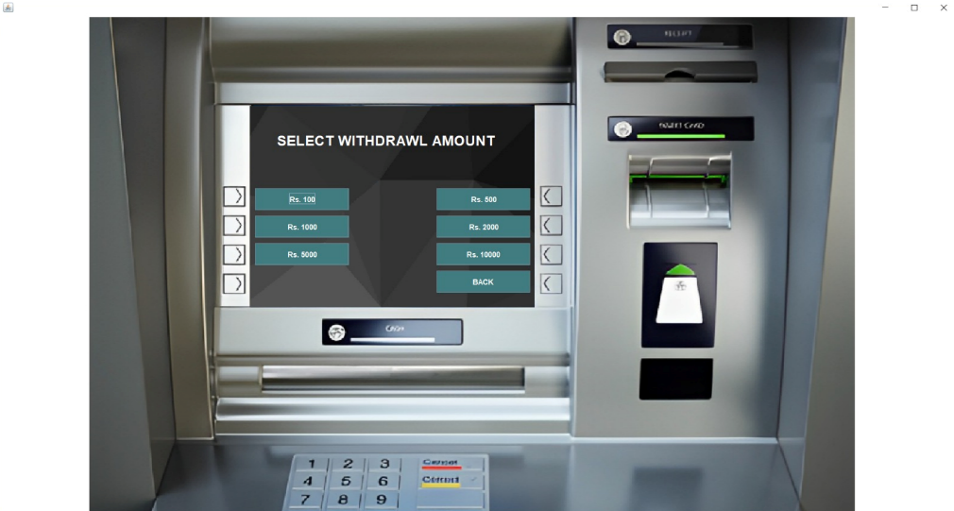

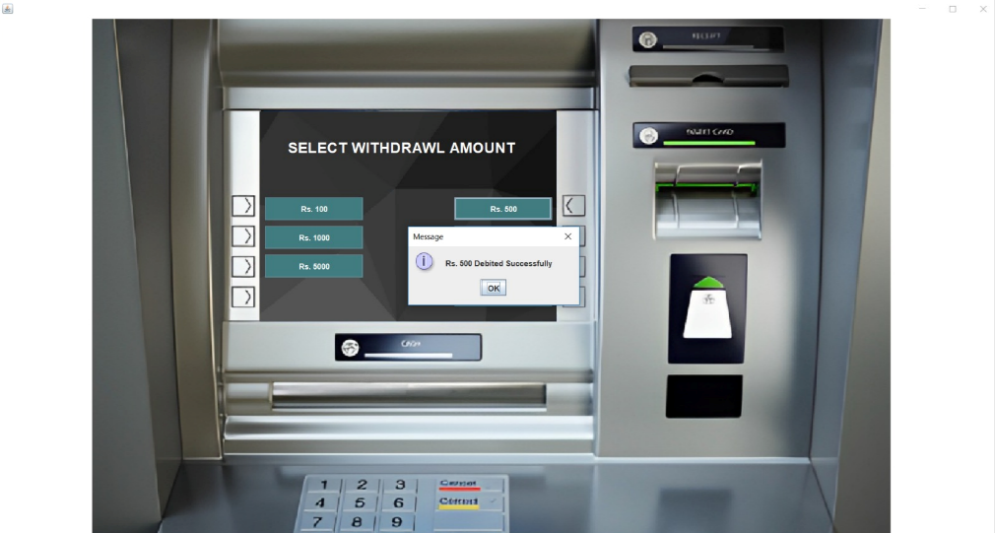

Balance Enquiry Code:

package bank.management.system;  
  
import javax.swing.*;  
import java.awt.*;  
import java.awt.event.ActionEvent;  
import java.awt.event.ActionListener;  
import java.sql.ResultSet;  
  
public class BalanceEnquiry extends JFrame implements ActionListener{  
  
String pin;  
 JLabel label2;  
 JButton b1;  
   
BalanceEnquiry(String pin){  
 this.pin =pin;  
  
  
 ImageIcon i1 = new ImageIcon(ClassLoader.getSystemResource("atm2.png"));  
 Image i2 = i1.getImage().getScaledInstance(1550,830,Image.SCALE_DEFAULT);  
 ImageIcon i3 = new ImageIcon(i2);  
 JLabel l3 = new JLabel(i3);  
 l3.setBounds(0,0,1550,830);  
 add(l3);  
  
 JLabel label1 = new JLabel("Your Current Balance is Rs ");  
 label1.setForeground(Color.WHITE);  
 label1.setFont(new Font("System", Font.BOLD, 16));  
 label1.setBounds(430,180,700,35);  
 l3.add(label1);  
  
 label2 = new JLabel();  
 label2.setForeground(Color.WHITE);  
 label2.setFont(new Font("System", Font.BOLD, 16));  
 label2.setBounds(430,220,400,35);  
 l3.add(label2);  
  
 b1 = new JButton("Back");  
 b1.setBounds(700,406,150,35);  
 b1.setBackground(new Color(65,125,128));  
 b1.setForeground(Color.WHITE);  
 b1.addActionListener(this);  
 l3.add(b1);

int balance =0;  
 try{  
 Connn c = new Connn();  
 ResultSet resultSet = c.statement.executeQuery("Select * from bank where pin = '"+pin+"'");  
 while (resultSet.next()){  
 if (resultSet.getString("type").equals("Deposit")){  
 balance += Integer.parseInt(resultSet.getString("amount"));  
 }else {  
 balance -= Integer.parseInt(resultSet.getString("amount"));  
 }  
 }  
 }catch (Exception e){  
 e.printStackTrace();  
 }  
   
 label2.setText(""+balance);  
  
 setLayout(null);  
 setSize(1550,1080);  
 setLocation(0,0);  
 setVisible(true);  
  
}  
@Override  
 public void actionPerformed(ActionEvent e) {  
 setVisible(false);  
 new main_Class(pin);  
 }  
public static void main(String[] args) {  
 new BalanceEnquiry("");  
 }  
}

Output:

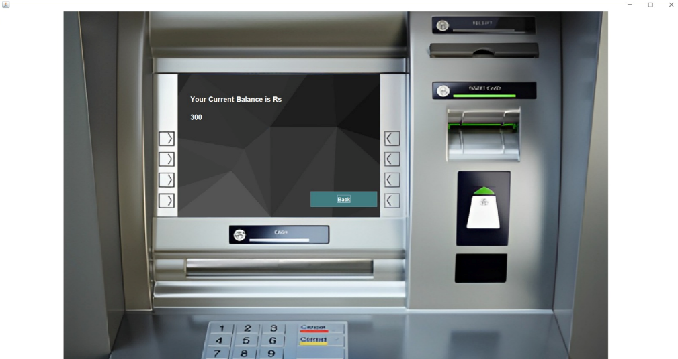

MINI Statement Code:

package bank.management.system;  
  
import javax.swing.*;  
import java.awt.*;  
import java.awt.event.ActionEvent;  
import java.awt.event.ActionListener;  
import java.sql.ResultSet;  
  
public class mini extends JFrame implements ActionListener {  
 String pin;  
 JButton button;  
 mini(String pin){  
 this.pin = pin;  
 getContentPane().setBackground(new Color(255,204,204));  
 setSize(400,600);  
 setLocation(20,20);  
 setLayout(null);  
  
 JLabel label1 = new JLabel();  
 label1.setBounds(20,140,400,200);  
 add(label1);  
  
 JLabel label2 = new JLabel("Mini Statement");  
 label2.setFont(new Font("System", Font.BOLD,15));  
 label2.setBounds(150,20,200,20);  
 add(label2);  
  
 JLabel label3 = new JLabel();  
 label3.setBounds(20,80,300,20);  
 add(label3);  
  
 JLabel label4 = new JLabel();  
 label4.setBounds(20,400,300,20);  
 add(label4);  
  
 try{  
 Connn c = new Connn();  
 ResultSet resultSet = c.statement.executeQuery("select * from login where pin = '"+pin+"'");  
 while (resultSet.next()){  
 label3.setText("Card Number: "+ resultSet.getString("card_number").substring(0,4) + "XXXXXXXX"+ resultSet.getString("card_number").substring(12));  
 }  
 }catch (Exception e ){  
 e.printStackTrace();  
 }  
  
 try{  
 int balance =0;  
 Connn c = new Connn();  
 ResultSet resultSet = c.statement.executeQuery("select * from bank where pin = '"+pin+"'");  
 while (resultSet.next()){  
  
 label1.setText(label1.getText() + "<html>"+resultSet.getString("date")+"&nbsp;&nbsp;&nbsp;&nbsp;&nbsp;"+resultSet.getString("type")+"&nbsp;&nbsp;&nbsp;&nbsp;&nbsp;"+resultSet.getString("amount")+ "<br><br><html>");  
  
 if (resultSet.getString("type").equals("Deposit")){  
 balance += Integer.parseInt(resultSet.getString("amount"));  
 }else {  
 balance -= Integer.parseInt(resultSet.getString("amount"));  
 }  
 }  
 label4.setText("Your Total Balance is Rs "+balance);  
 }catch (Exception e){  
 e.printStackTrace();  
 }  
  
 button = new JButton("Exit");  
 button.setBounds(20,500,100,25);  
 button.addActionListener(this);  
 button.setBackground(Color.BLACK);  
 button.setForeground(Color.WHITE);  
 add(button);  
  
 setVisible(true);  
 }  
  
 @Override  
 public void actionPerformed(ActionEvent e) {  
 setVisible(false);  
 }  
  
 public static void main(String[] args) {  
 new mini("");  
 }  
}

Output:

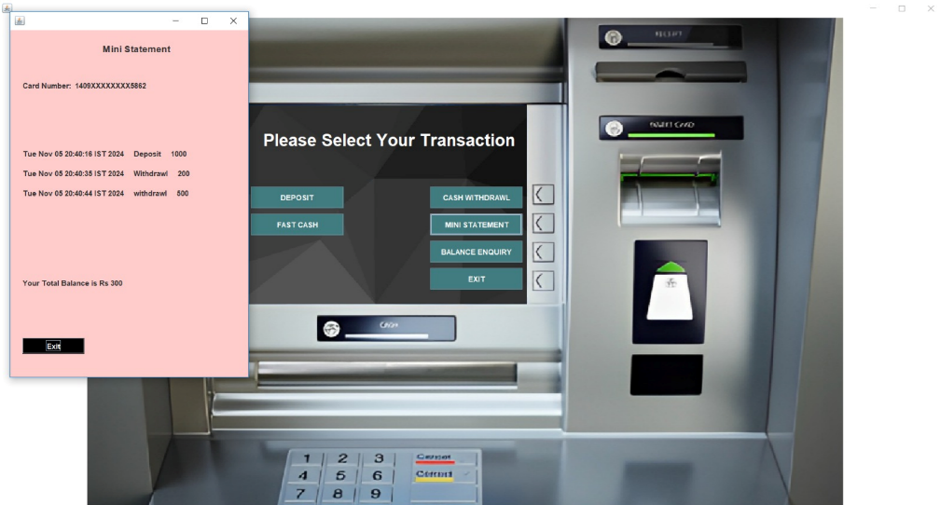

Database Code:

create database bankSystem;

use bankSystem;

create table signup(form_no varchar(30),name varchar(30),father_name varchar(30),DOB varchar(30),gender varchar(30),email varchar(60),marital_status varchar(30),address varchar(30), city varchar(30), pincode varchar(30), state varchar(50));

select * from signup;

create table signuptwo(form_no varchar(30),religion varchar(30),category varchar(30), income varchar(30),education varchar(30),occupation varchar(60),pan varchar(30),aadhar varchar(30), seniorcitizen varchar(30), existingaccount varchar(30));

select * from signuptwo;

create table signupthree(form_no varchar(30),account_type varchar(40), card_number varchar(30), pin varchar(30), facility varchar(200));

select * from signupthree;

create table login(form_no varchar(30),card_number varchar(50), pin varchar(30));

select * from login;

create table bank (pin varchar(10), date varchar(50), type varchar(20), amount varchar(20));

select * from bank;

Output:

